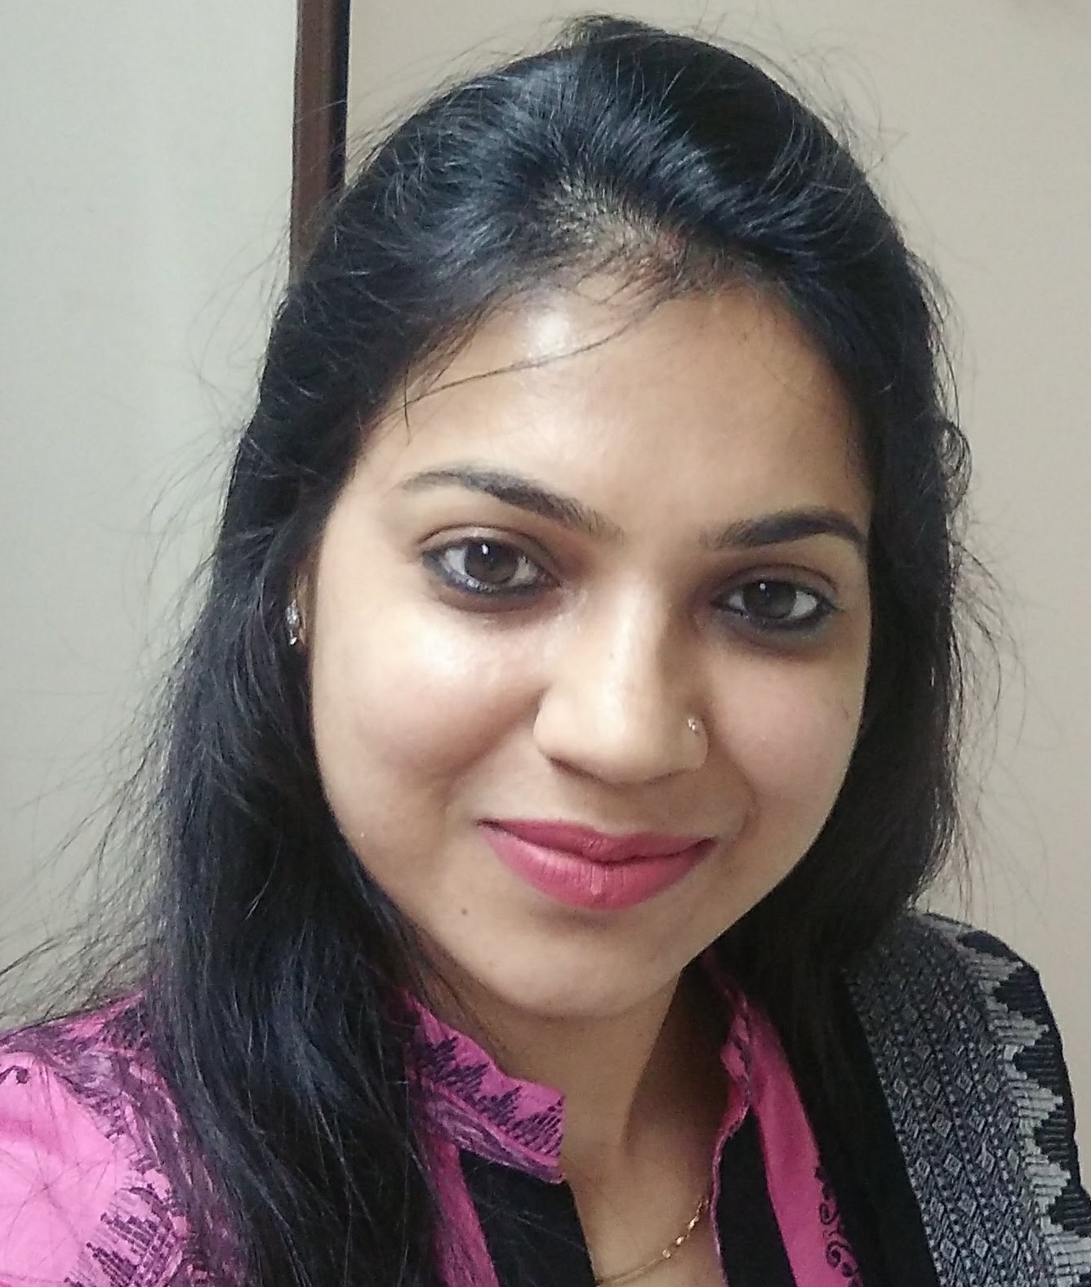
MEENAKSHI SHARMA
Mobile: 91 9811767329, 9871671624 Tel: 011-22731125
Email: meenu.sharma22@gmail.com

Job Objective: In pursuit of HR assignments with an organization of high repute

PROFILE SUMMARY
- A multi-faceted enthusiastic and competent HR professional with experience of more than 12 years in all areas of human resource management around people strategy, HR programs and operations. Worked for cross-functional industries under one group like Infrastructure, Power, IT enabled services, Environmental advisory, Organic Fertilizers. Handling HR function for manpower strength of 800 on-roll and more than 5,000 contract manpower. Well adept in aligning the HR goals with the business plans, and role involves:
Manpower Planning | Talent Acquisition | Induction & On-Board | Performance Management
HR Manual & EHB | Learning & Development | HR Audit | HRIS
Employee Relations | Employee Engagement | HR Operations and Compliances

- A keen planner with expertise in managing entire HR gamut with focus on profitability by ensuring optimal utilization of resources and strategic management.
- Well versed with the concepts of Quality Management System (ISO 9001:2008)
- An effective communicator, motivator with good interpersonal skills and positive attitude to interact effectively with people at all levels. .
- Well adept in managing employee relations and executive level expectation in HR.

PROFESSIONAL EXPERIENCE
- Currently employed as an Assistant Manager – HR with IL&FS Environmental Infrastructure & Services Limited, at corporate office, New Delhi since April 2011 - till Date.
- Executive – HR with IL&FS Ecosmart Limited from December 2007 to March 2011, handled independently complete HR functions for IT division of 200 on-roll employees and 100 third party rolls. The Company provide advisory services in Geo-spatial & IT enabled services. It is an ISO 9001:2008 and Cmmi Level 3 certified provides sustainable solution framework integrated with spatial technology.
- Executive - Administration & HR at Regional Office Delhi with Carl F India Pvt. Ltd. since May 2006 - November 2007, a Denmark based conglomerate is into manufacturing of Stainless steel handrails, hardware, bathroom accessories and architectural products did landmark projects in Infrastructure development presently running operations under Q-Railing India.

PRESENT COMPANY PROFILE
IL&FS Environmental Infrastructure & Services Limited, a wholly owned subsidiary of IL&FS Ltd., has established several benchmarks in the Geo Spatial solutions & IT enabled services, Environment Infrastructure and Waste Management service sector with successful implementation of pioneering projects. The Company has innovated viable waste processing business model for its asset based Integrated Waste Management Service sector.
The Company is doing mandates across 36 sites in 10 States to manage about 16400 tonnes of waste every day and is amongst the first to mainstream Carbon financing in waste management. IEISL has successfully created a niche in the Waste Sector by recycling organic waste into organic fertilizer, Construction & Demolition waste to recycled building waste materials and combustibles into green power. The Company deals with scientific handling, collection, sorting and transportation of municipal solid waste generated in households, market places, commercial establishments, etc. We also intend to raise awareness about the importance of segregation at source.
For more details please visit www.ilfsenv.com and www.ilfsindia.com

ACHIEVEMENTS
- Drive IL&FS various developmental programs in IEISL like IL&FS Ethos training to each one of the employee in the group, Voice of the Employee, different talent development programs at Junior, Middle and Leadership level.
- Undertaken the Initiative of Employer branding among new / upcoming Talent pool by presenting company’s business and HR policies presentation at various Colleges’ Campus and institutions to attract talent.
- Set up complete HR function for Three Subsidiary companies starting from Manpower planning to HR operations and HR Audits.
- Implemented Online PMS system for the group.
- Formulation and Implementation of HR manual & Employee Handbook for company, it comprises company values, service code of conduct, HR & employment policies, rules & practices, perquisites, benefits, entitlements etc. along with various formats, SOPS, flowcharts of HR functions.
- Undertaken Initiative to introduce Web based HR applications in the form of HR portal and strengthened employee communication by means of e-News Letter, e-Greetings, birthday greetings. HR Sandesh Id’ for various management communications thoughts, Welcoming new hire.
- Conceptualized and implemented an Induction Programme for new hire on boards at group level.
- Periodically Planned and Organized HR workshops and represented the Talent Acquisition function at corporate level.
- Organization structuring for all business verticals linking to existing manpower and forecast to analyze better manpower needs and rationalization.
- Established Buddy Programme in the organization.
- Initiated & successfully implemented HRIS system among group, updating HR dashboard and management update.
- Initialization and Documentation of HR Process for ISO 9001:2008 certification and CMMi L-3, Company achieved L- 3 Certification and going for Level 5
CORE COMPETENCIES
- Manpower Planning & Talent Acquisition: Executing Manpower planning for new projects and existing project reviews, preparing Organograms, organizing approvals for Budgeting, developing JDs, job postings on Naukri portal, identifying potential candidates, interviewing on preliminary basis, organizing interviews, negotiations, preparing CTC structures, ensuring background verification check, ensuring approvals and facilitating the placements. Later, Analysis Budgeted and Actual manpower gaps.
Set up complete HR function for Three Subsidiary companies staring from Manpower planning to HR operations.
  - Initiated Feedback of Recruitment Quality to analyze and plan the training for the resources placed in the department.
- Organization Structuring: Designing & updating Organogram at various Departmental levels for Organizational structuring after complete understanding of reporting relationship matrix in verticals.
- HR Manual and Employee Handbook: Formulate and implement the HR manual and Employee Handbook of the company. Also taking care of annual updation and amendment of various policies and formats.
- Induction & Orientation: Conducting orientation programme of new hires, Initiative taken in conceptualizing and preparing the Induction presentation & feedback program for new entrants to facilitate smooth assimilation of company’s culture and build Buddy culture.
- Training & Development:
    - Training needs analysis from PMS and competency mapping, preparing T&D calendar inclusive of safety trainings, training budget, identifying faculties (Internal and External), finalizing training partners and organizing training programs.
    - Encouraging Managers in preparing skill matrix, as per required skill level/project need arrange trainings as proposed/identified during skill mapping.
    - Preparing training feedback and effectiveness, ensuring the record keeping for T&D.
    - Organized various trainings on Team Building, Capacity Building and outdoor activities, MS tools like Excel, Power Point, Dashboards, Product pricing, Win-Win Negotiation, Business Communication, Healthy Lifestyle, Stress management, Yoga, Tax and Investment planning, encouraging employees to participate in conclaves and forums for knowledge enrichment, Safety trainings like First Aid, PPE equipment’s handling, Women Self Defense, Sexual harassment awareness and many more.
- Performance Management: Handling complete performance appraisal process, doing competency mapping formulating various communications & helping employees to complete appraisal cycle, conducting training for PMS implementation, bell curve distribution on ratings and balance score card. Handling Job-chats, Mid-term reviews.
- HR operations and Compliances:
    - Payroll Management: Attendance and Leave management through Biometric system. Salary processing through ERP software (Axapta), F&F settlements, periodic leaves encashment, Reimbursements, EPF & ESI compliances Challans and Returns etc. Ensuring compliances under various applicable Factory Acts and Laws, Sexual Harassment Act etc.
    - Group Gratuity Scheme: Handled the Implementation of Group Gratuity Scheme for the company after the merger of three companies and ensuring legal requirements while creating scheme in conjunction with LIC. Managing Trust and Fund Manager Compliances and Policy renewals.
    - Employee data base management.
    - Handled complete joining and exit processes.
    - Employee Background Verification process for strengthen the quality of talent hired.
- HRIS and Budgeting: Preparing presentations for HR reviews, ensuring the updation of employee master periodically, preparing HR budget, Monthly HRIS, producing various other reports like attrition and exit analysis report, new joiners report, manpower compensation report, compliance report etc.
- HR Audits: Independently handling HR Internal and External Audits, Interfacing with Auditors, preparing HR submission on reports and Action points.
- Employee Relations & Engagement activities:
    - Drive Implementation of Reward and Recognition policy in the Company.
    - Grievance Redressal: General discussion with employees regarding absenteeism, formulating various Absentee/Absconding communications. Resolutions with one-to-one/group discussions & motivating employees to maintain discipline. Started HR helpdesk for resolving employees’ queries with TAT. Formed Grievance Redressal committee with SOP for resolution within TAT.
    - Initiated Fun Committee and actively participated and took lead as a member for initiating recreational activities like festival celebration, employee birthday celebration, picnics, get-togethers, organized cricket match, painting competition, employee welcome communications etc to strengthen employee engagement. HR Conciliation “Samadhan” meetings.
    - Initiated HR Help Desk for general employee queries.
- OD Initiatives:
    - Strengthened employee communication by formulating and successfully establishing Web based HR applications like e-News Letter and various templates of HR in portal.
    - Hi-Pot analysis, Succession Planning, Performance Improvement Plans (PIP), Career Development Planning, Job-Rotations, Job Enrichment, Designed Employee Satisfaction Survey, Reward and Recognition Program, Psychometric testing through Thomas Assessments and WheeBox and done various analysis for employee development. HR Suggestions tracker and follow-ups for implementation.
    - Handled Implementation of HRMS module for ERP.
- Quality Management System and CMM I L-3: Developed QMS (ISO 9001: 2008) HR procedure for one of the ITeS vertical, Adherence to QMS procedure, maintaining & updating records, sending monthly data to MR, Handling the periodic quality audits and Surveillance Audits. Ensuring meeting QMS targets and achieving continual improvement.
- Training, mentoring the interns, preparing the plans of their On-the-job training and monitored their progress on assigned projects. Evaluation their performances and recommending for absorption in the Company.
EDUCATIONAL QUALIFICATION
- Diploma in Training and Development from Indian Society of Training & Development, 2012
- PGDM (HRM) from Institute of Management Technology (IMT), Ghaziabad 2009
- B.Com (Hons.) from Delhi University, Maharaja Agrasen College, 2005
MEMBERSHIPS
Member of ISTD and National HRD.
IT skills and ERP
- Well versed with MS Office, MS Visio, MS Publisher, Internet Applications
- ERP : Oracle HRMS module, Farsight, MS Axapta

PERSONALITY TRAITS & SKILLS
- Strengths: Talent Strategist, People Management Skill, Multi-tasking, Analytical, Quick Learner, Problem Solver, Quick Decision Maker, Good team player, Creative.
- Leisure time activities: listening songs, watching movies, reading, shopping, social sites.

PERSONAL DETAILS
Date of Birth : 06th February, 1985
Father’s Name : Shri Ramesh Sharma
Husband : Mr. Amit Rattan
Kid : One Son
Gender : Female
Marital Status : Married
Languages Known : Hindi & English
Address : 206 C, Pocket C, Mayur Vihar Phase – II, Delhi – 110091

Date:
Place: Delhi (MEENAKSHI SHARMA)

